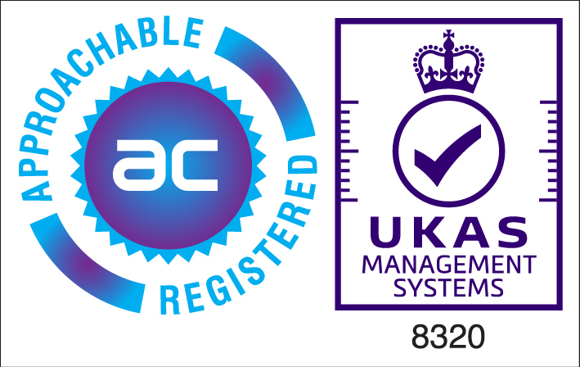

Certificate Number 11093
(Labour Provider to the construction Industry (Inc banks man, traffic marshals and security operatives)

